Exam 1 Review

- Consider the area bounded by the curve and the x-axis for . Set up, but do not evaluate, integrals for each of the following.

- The volume of the solid obtained when the function is rotated around the line .

- The volume of the solid obtained when the function is rotated around the line .

- The length of the curve.

Note that is continuous on . Therefore

- The surface area obtained by rotating the curve about the y-axis.

Note that is continuous on and is non-negative on . Therefore,

- The surface area obtained by rotating the curve about the x-axis.
Note that is continuous on and is non-negative on . Therefore,

- Consider the shaded region that is bounded by the curves and (shown below).
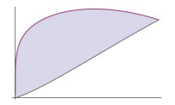
- Setup, but do not evaluate, an integral which represents the area of the region.

- Suppose that the given region is the base of a solid where the cross sections parallel to the y-axis are rectangles which are half as tall as they are wide. Setup, but do not evaluate, an integral which represents the volume of this solid.

- Setup, but do not evaluate, an integral which represents the volume of the solid obtained when the given region is rotated about the x-axis.

- Consider the region bounded by the curves , , and .
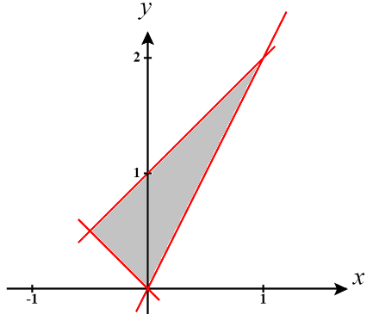
We see that the intersections of these curves are:

- Determine the area of the region by integrating with respect to x.

- Determine the area of the region by integrating with respect to y.

We solve each of our functions for x.

- Setup, but do not evaluate, an integral(s) that represents the volume of the solid obtained when the region is revolved about the line .

(i) Integrate with respect to x.

(ii) Integrate with respect to y.

- A 60m climbing rope is hanging over the side of a tall cliff. How much work is performed in pulling the rope up to the top, where the rope has a mass of g/m?

I will imagine labeling the top of the rope as height 0 and the bottom as height 60m.
The rope is 60m long and has a mass of 0.066kg/m so that means that the cable has a mass of .
The force required to lift any cross section is:

The distance any cross section needs to be pulled is:

So, the work needed for any given cross section is:

The integral we need is:

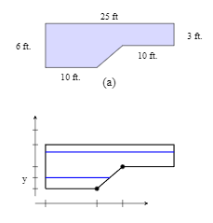
- A rectangular swimming pool is 20ft wide and has a 3ft “shallow end” and a 6ft “deep end”. A full picture of the pool and its dimensions are shown in the diagrams below. Determine the total amount of work needed to pump the water to the top of the pool. (The density of water is )

We first note that the shape of the cross sections of water in the pool are not always the same we will have to evaluate the total work by using two different integrals.

Consider the bottom of the pool as height 0 and the top of the pool as height 6.

For we have cross sections with depth and length 25ft and width of 20ft. So, for a single cross section of the tank:

Therefore, we define the total work for this portion of the water is .

For we have cross sections with depth a width of 20ft and a variable length. We will imagine the pool’s bottom left corner is positioned at the origin.
Note that the sloped portion of the bottom of the pool is given the equation . The length for this portion of the pool are represented by .
So, for a single cross section of the tank:

Therefore, we define the total work for this portion of the water is .
So, the entire work is given by

